
BEYERS PREMIUM MIXTURES
THE QUALITY OF THE CHAMPIONS

From a quality point of view, the PREMIUM mixtures are the supreme products within the BEYERS range. The emphasis is on the smaller types of grain in the premium mixtures, like small Cribbs maize and small peas, in combination with toasted soya, in order to guarantee optimal absorption of the grains. Whoever opts for PREMIUM mixtures opts to never throw money down the drain again. Plus the composition of these mixtures is of such high quality that we can refer to this as optimally nutritious. This will allow you to get the very most out of your pigeons’ qualities.

BEYERS PREMIUM VANDENABEELE – 20KG – 44 LBS
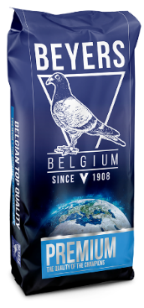
- Easily digestible and low-protein racing mixture, rich in carbohydrates and fats.
- Main ingredients: Small cribbs maize, sorghum, safflower seed and brown rice.
- This mixture is ideal as a main feed for short distance races up to 90 miles (< 2 flight hours). When participating in longer short distance races (between 90 and 150 miles) as a feed at the beginning of the week, this in combination with PREMIUM SUPER WIDOWHOOD, PREMIUM YOUNGSTERS, GALAXY SPORT LIGHT or PREMIUM HI-DIGEST ENERGY during the last feedings.
Ingredients: maize small cribbs, sorghum white, safflower seed, brown rice, barley, oats peeled, wheatwhite, mungbeans, sorghum red, buckwheat, linseed, rape seed.
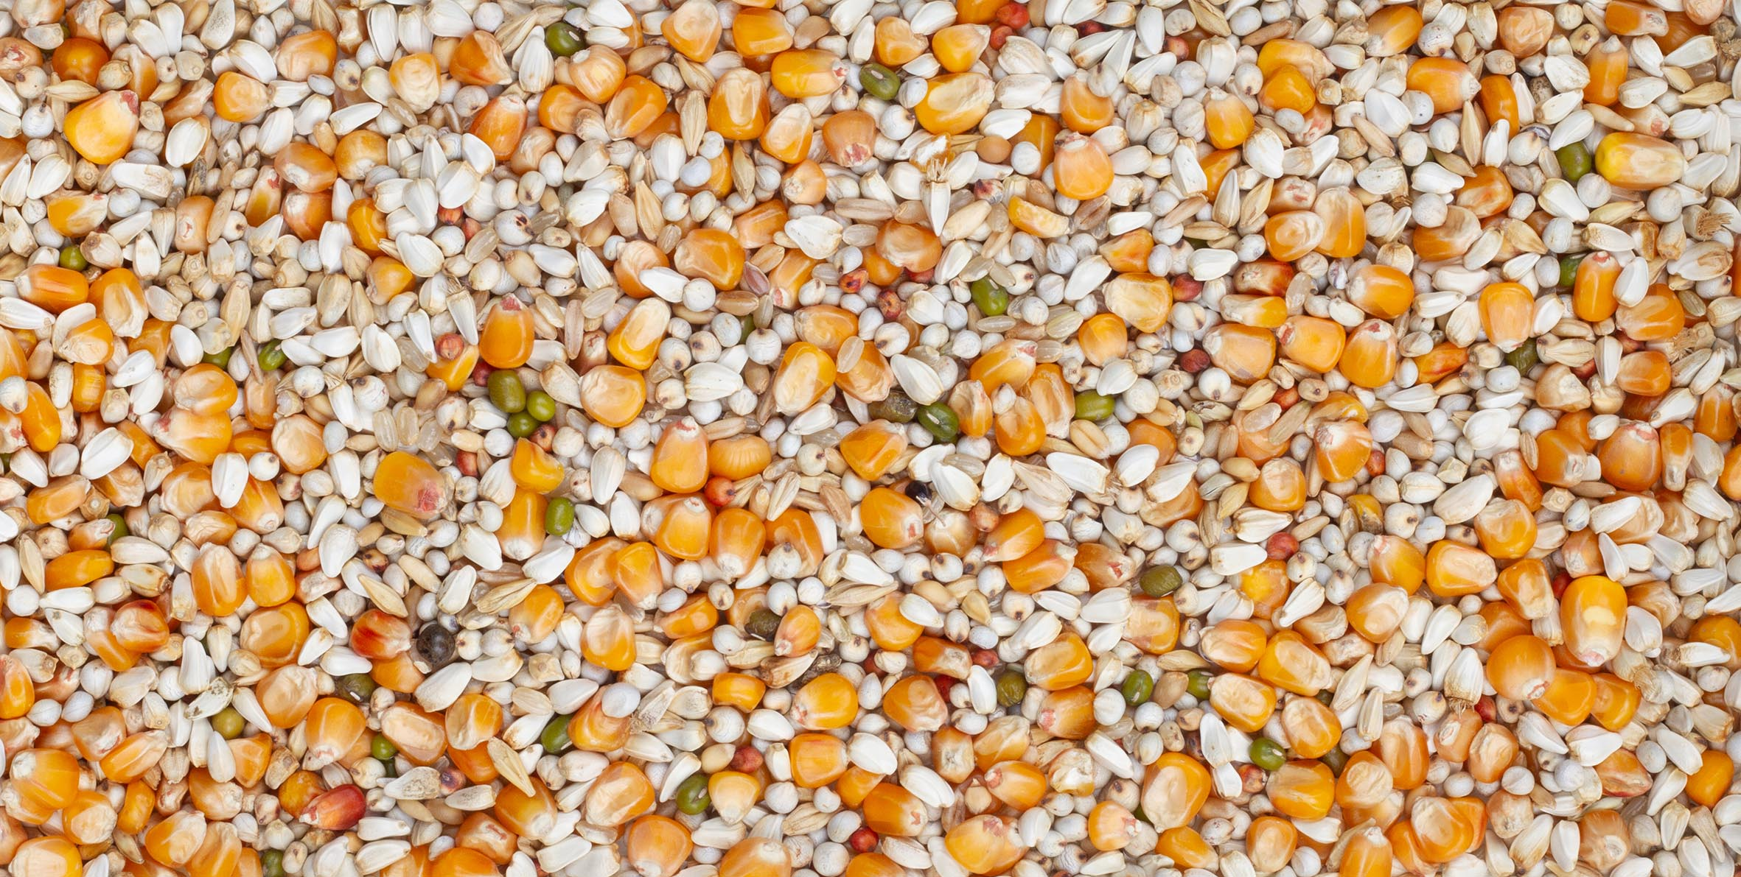

Carbohydrates | 57,90%
Crude protein | 11,20%
Crude fat | 8,60%
Crude fibre | 8,70%
Crude ash | 1,70%

